**Pre-Experiment Setup B**

Follow the next instructions in order to have a SPL example running. Next you will be required to make some modifications or additions.

**FOR THIS EXPERIMENT YOU NEED TO HAVE INSTALLED:**

* Java (JDK)
* VariaMos
* Eclipse Oxygen EE
* Apache Tomcat

**CONFIGURING VARIAMOS:**

1. Go to this link: <https://mega.nz/#!3UBSDKBJ!EJcekrk9NXzNVMYV-_-SQ_ra0xGLbv13IXI0AjV2PJs> and download all the content
2. Decompress ExperimentB.zip inside a folder called “Xtores”
   1. This folder contains the pool of components and the derivation folder (Derived)
3. Open VariaMos (Component-based project)
4. Go to File -> Load File and load the xmodel.vmum

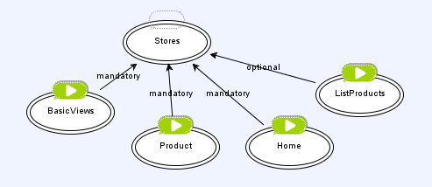

1. Go to “Domain Implementation” -> “Set derivation parameters” and configure the proper paths based on your location

